Our AI Approach
o
u
n
t
o
l
A
c
c

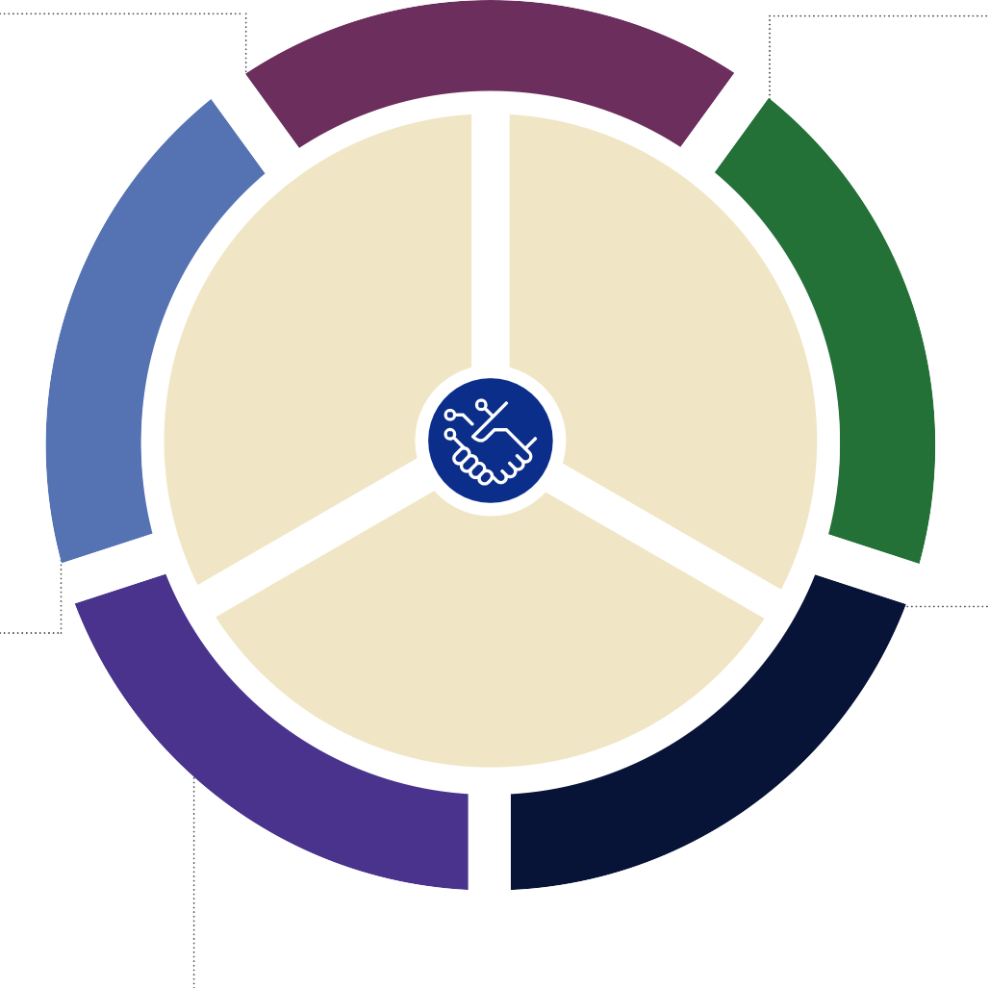
Adaptable
GOAL
Ensure AI is used responsibly and effectively.
TEACHER TRAINING
- AIl teachers receive ongoing training on appropriate, effective AI use.
OVERSIGHT & EVALUATION
- AI tools and practices are reviewed by a team of educators, tech experts, and parents.
School Accountability
a
b
i
l
i
t
y
S
a
f
e
t
I
n
s
t
r
u
c
t
i
o
n
S
c
h
o
We update our approach as AI technology evolves.
P
e
r
s
o
n
a
l
i
z
e
d

Inclusive
Every student benefits equally from AI tools.
GOAL
Keep student data and content safe.
DATA PRIVACY
- Student information is never shared without permission.
- Strict security measures protect all data.
CONTENT SAFEGUARDS
- AI tools include filters and are monitored by teachers.
- AIl classroom AI content is teacher approved and aligned to district standards.
Safety & Protection
y
&
P
r
o
t
e
c
t
i
o
n

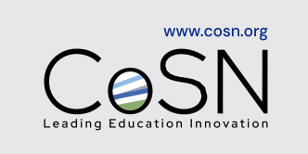

Transparent
GOAL
Teach students to use AI responsibly.
- Students learn when AI is useful and when it’s not.
- They practice verifying AI provided information.
AI Literacy
Personalized Instruction
We keep you informed about child’s education.
GOAL
Tailor instruction to student needs.
- Extra help where your child needs it.
- Acceleration where they excel.
s
t
f
e
n
e
B
g
n
i
n
r
a
e
L
y
c
a
r
e
t
i
L
I
A
how AI is used in your

GOAL
Enhance education and prepare students for the future.
- AI enhances instruction and supports future ready skills.
- Prepares students for a world where AI is common.
Learning Benefts

